# **INT105 - DBMS LAB**

# **SQL commands for table manipulation (Create, Alter, Drop Statements and Key Constraints)**

# **Table Name: Product_Info**

|  |  |
| --- | --- |
| Column Name | Purpose |
| Maker | Name of the maker/manufacturer of computers/peripherals |
| Model_No | The unique identifier for each product manufactured |
| Type | Indicates the type of the product – PC for personal computers, LP for Laptop and PR for printers |

**Table Name: PC**

|  |  |
| --- | --- |
| Column Name | Purpose |
| Model_No | The unique identifier for each PC |
| Speed | Clock Speed of the PC |
| RAM | RAM in MB |
| HD | The hard-disk capacity of the PC in GB |
| CD | The speed of the CD Drive |
| Price | Price of the PC |

**Table Name: Laptop**

|  |  |
| --- | --- |
| Column Name | Purpose |
| Model_No | The unique identifier for each Laptop |
| Speed | Clock Speed of the PC |
| RAM | RAM in MB |
| HD | The hard-disk capacity of the PC in GB |
| Screensize | Screensize of the laptop |
| Price | Price of the PC |

**Table Name: Printer**

|  |  |
| --- | --- |
| Column Name | Purpose |
| Model_No | The unique identifier for each Laptop |
| Color | Flag indicating whether it is a color printer or a black and white printer |
| Type | Line, InkJet or Laser |
| Price | Price of the printer |

Product_Info PC

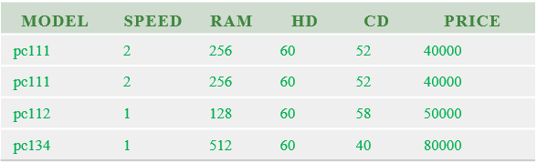

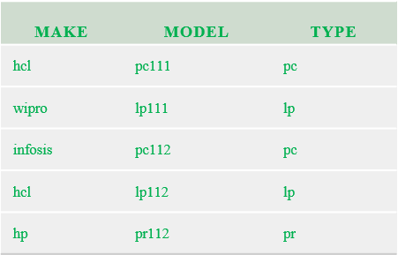

Printer

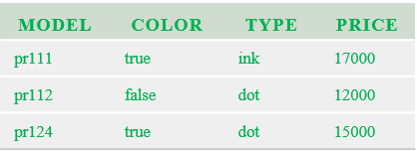

The product_info table serves as a master table containing the list of all models of pc, laptop and printers manufactured by all makers. The PC, Laptop and the printer table give specific details about each product in that class.

1. Create the 4 tables mentioned above
   1. Check if the table is created successfully (tab table)
2. Alter the table product_info to make the type column NOT NULL.
3. Alter the table pc to have a default speed of 2.
4. Create suitable primary keys for all the tables of the above database schema
   1. Check if the primary keys are created successfully (User_Constraints table)
5. Create suitable foreign keys for all the tables of the above database schema
   1. Check if the foreign keys are created successfully (User_Constraints table)
   2. Demonstrate the usage of On delete cascade
6. Check Constraints:
   1. Apply a check constraint on the product_info table such that the only permitted values for the type column are ‘pc’, ‘lp’ and ‘pr’.
   2. Apply a check constraint such that the prices of pc, laptop and printer are all positive.
   3. Check if the check constraints are created successfully (User_Constraints

table)

1. What are the different values for constraint_type in the user_constraints table and what is the meaning of each of those values?
2. Modify the table printer by adding a column printercode of type varchar2(10) to identify the printer uniquely in the world.
3. Add a Unique key constraint in the printercode column.
   1. Check if the unique key constraint is created successfully (User_Constraints table)
4. Increase the width of the column printercode by 2.
5. Without removing the table definition from the database remove all the rows from the table ‘Type_info’.
6. Drop the table ‘type_info’ from the database.